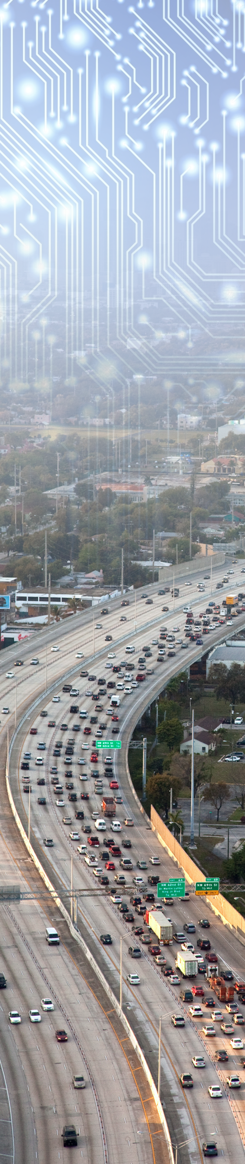
Contract #: DTFH6116D00035
TOPR #: HOIT212116217

JPO
Operational Data Environment
User Guide

Submitted to:
U.S. Department of Transportation (USDOT)
Federal Highway Administration ITS JPO

February 9, 2018

Prepared by:
Booz Allen Hamilton
8283 Greensboro Drive
McLean, VA 22102

This page intentionally blank

Booz Allen Hamilton
8283 Greensboro Drive
McLean, VA 22102-3838
Tel 703-902-5000
Fax 703-902-3333
www.boozallen.com

Contents
Version History 6
1 Introduction 7
2 Project Overview 7
3 System Overview 8
4 Audience 8
5 Glossary 9
6 ODE DEVELOPMENT ENVIRONMENT 11
6.1 Java Development Tools 11
6.2 Java 11
6.3 Eclipse IDE 11
6.4 Maven 11
6.5 Git Version Control 11
6.6 Building ODE Software Artifacts 12
6.6.1 Open-Source Repository 12
6.6.2 Private Repository 12
6.6.3 ODE Application Properties 13
6.6.4 ODE Logging Properties 16
7 ODE Features 17
7.1 Managing SNMP Devices 17
7.1.1 Query Parameters 17
7.1.2 API Details 18
7.1.3 Web Based View 18
7.1.4 Additional Features/ Discussion Points 18
7.2 Logging Events 18
7.2.1 Log Levels 18
7.2.2 Logging setup 19
7.2.3 Steps to turn on/off logging during application runtime. 19
7.3 IEEE 1609.2 Compliance 20
7.4 SCMS Certificate Management 20
7.5 Inbound BSM Distribution 20
7.6 Probe Data Management 20
7.6.1 PDM Broadcast Request Quick Start Guide 20
7.7 Outbound TIM Broadcast 21
7.7.1 Outbound TIM Setup 21
7.7.2 TIM Broadcast Request Quick Start Guide 22
7.8 Privacy Protection Module (PPM) 22
7.9 Inbound TIM Distribution 23
7.10 Data validation 23
7.11 Data Sanitization 23
7.12 VSD Deposit Service 23
7.12.1 VSD Deposit Service Messages and Alerts 24
7.13 VSD Receiver Service 25
7.13.1 VSD Receiver Service Messages and Alerts 26
7.14 BSM Receive Service via UDP 28
7.14.1 BSM Receiver Service Messages and Alerts 28
8 Appendix A: ODE Interface Specification 29
8.1 File Copy Data Deposit 29
8.1.1 Messages and Alerts 29
8.2 ODE REST API 32
8.2.1 Upload BSM File 35
8.2.2 MANAGE SNMP API 36
8.2.3 Traveler Information Message (TIM) Interface 37
8.2.4 Probe Data Management Messages (PDM) Interface 38
8.3 ODE Streaming API 39
8.3.1 Direct Kafka Interface 39
8.3.2 ODE WebSocket Interface 40
8.4 ODE Request Schemas 42
8.4.1 ODE Request Message Metadata 42
8.5 ODE Response Schemas 43
8.5.1 ODE Data Message 43
8.5.2 ODE Message Metadata 43
8.5.3 ODE Payload Violation 45
8.5.4 ODE GET TOKEN Response 45
8.5.5 ODE Status Message 46
8.5.6 ODE Control Message 46
8.5.7 ODE Data Message Payload 47
8.5.8 ODE Data Message Supporting Data Structures 48

Version History
Version # | Implemented By | Revision Date | What Changed?
0.1 | Hamid Musavi |  | Initial draft
0.2 | Hamid Musavi | 3/6/2017 | Updated document for ODE-146
0.3 | ODE Team | 3/14/2017 | Added outbound TIM documentation
0.4 | ODE Team | 3/28/2017 | Added PDM documentation
0.5 | Hamid Musavi | 5/9/207 | Added support for System Design Documentation
0.6 | ODE Team | 5/23/2017 | Added PPM Documentation
0.7 | ODE Team | 5/30/2017 | Added VSD documentation
0.8 | ODE Team | 6/02/2017 | Added BSM documentation
0.9 | ODE Team | 8/28/2017 | Updated properties table. TIM/PDM REST details moved to Swagger document.
0.10 | ODE Team | 9/1/2017 | Added BSM log file handling
0.11 | ODE Team | 10/31/2017 | Updated for open-ode
0.12 | ODE Team | 1/10/2018 | Updated SDC/SDW WebSockets end-point
0.13 | ODE Team | 1/23/2018 | Documented changes related to schemaVersion 4

Introduction
The JPO Operational Data Environment (ODE) product is being developed under Agile Development Methodologies, using an open architecture approach, in an open source environment. This document describes the preliminary architectural design of the JPO ODE and its interfaces with external systems including the TMC applications, field devices and center services.
Note: This is a living document and will be updated throughout the life of the JPO ODE project to reflect the most recent changes in the ODE design and stakeholder feedback. All stakeholders are invited to provide input to this document. Stakeholders may direct all input to the JPO Product Owner at DOT, FHWA, JPO. To provide feedback, we recommend that you create an “issue” in the project’s GitHub repository (https://github.com/usdot-jpo-ode/jpo-ode/issues). You will need a GitHub account to create an issue. If you don’t have an account, a dialog will be presented to you to create one at no cost.

Project Overview
An Operational Data Environment is a real-time data acquisition and distribution software system that processes and routes data from Connected-X devices – including connected vehicles (CV), personal mobile devices, infrastructure components, and sensors – to subscribing applications to support the operation, maintenance, and use of the transportation system, as well as related research and development efforts.
The ODE is intended to complement a connected vehicle infrastructure by brokering, processing and routing data from various data sources, including connected vehicles, field devices, Transportation Management Center (TMC) applications and a variety of other data users. Data users include but not limited to transportation software applications, Research Data Exchange (RDE), US DOT Situation Data Warehouse.
As a data provisioning service, the ODE can provision data from disparate data sources to software applications that have placed data subscription requests to the ODE. On the other direction, the ODE can accept data from CV applications and broadcast them to field devices through Road Side Units (RSU) and US DOT Situation Data Warehouse which in turn will transmit the data to Sirius XM satellites for delivery to the connected vehicles in the field.
While provisioning data from data sources to data users, the ODE also will perform necessary security / credential checks and, as needed, data validation and sanitization.
- Data validation is the process of making a judgment about the quality of the data and handling invalid data as prescribed by the system owners.
- Data sanitization is the modification of data as originally received to reduce or eliminate the possibility that the data can be used to compromise the privacy of the individual(s) that might be linked to the data.

System Overview
JPO ODE is an open-sourced software application that will enable the transfer of data between field devices and backend TMC systems for operational, monitoring, and research purposes. The system will enable applications to submit data through a variety standard interfaces as illustrated in the figure below.
The mechanisms chosen for a specific deployment will depend on the infrastructure, technical resources, and applications available to an ODE environment.
The JPO-ODE will be designed to support the producers and consumers of CV data as illustrated in Figure 1 below. The implementation timeline for the identified interfaces will depend on the needs of the JPO ODE customers (Wyoming CV Pilot site, initially) and the priority of these capabilities to the JPO-ODE product owner.

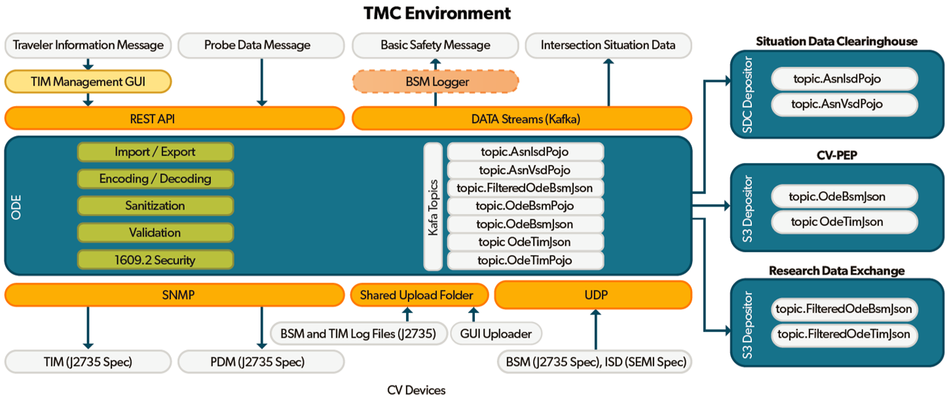
Figure 1 - ODE System Data Producers and Consumers

Audience
This document is intended for use by the ODE client applications.

Glossary
Term | Description
API | Application Program Interface
ASN.1 | Abstract Syntax Notation One (ASN.1) is a standard and notation that describes rules and structures for representing, encoding, transmitting, and decoding data in telecommunications and computer networking
Git | Git is a free and open source distributed version control system designed to handle everything from small to very large projects with speed and efficiency. https://git-scm.com/
JDK | Java Development Kit
JPO | Joint Program Office
JRE | Java Runtime Environment
JVM | Java Virtual Machine
Kafka | Apache Kafka is publish-subscribe messaging rethought as a distributed commit log.
POJO | Plain Old Java Object
SAE | SAE International is a global association of more than 128,000 engineers and related technical experts in the aerospace, automotive and commercial-vehicle industries.
J2735 | This SAE Standard specifies a message set, and its data frames and data elements specifically for use by applications intended to utilize the 5.9 GHz Dedicated Short Range Communications for Wireless Access in Vehicular Environments (DSRC/WAVE, referenced in this document simply as “DSRC”), communications systems.
SCP | Secure Copy
SDW | Situation Data Warehouse
TIM | Traveler Information Message
US DOT | Unites States Department of Transportation
WebSocket | WebSocket is designed to be implemented in web browsers and web servers, but it can be used by any client or server application. The WebSocket Protocol is an independent TCP-based protocol. Its only relationship to HTTP is that its handshake is interpreted by HTTP servers as an Upgrade request.
ZooKeeper | Apache ZooKeeper is a centralized service for maintaining configuration information, naming, providing distributed synchronization, and providing group services.

This page intentionally left blank

ODE DEVELOPMENT ENVIRONMENT

Java Development Tools
The ODE team uses Java as the primary programming language.
Tools:
- Java
- Eclipse IDE
- Git
- Maven
- GitHub: https://github.com/usdot-jpo-ode/jpo-ode

Java
Install Java Development Kit (JDK) 1.8
http://www.oracle.com/technetwork/java/javase/downloads/jdk8-downloads-2133151.html

Eclipse IDE
Download and install Eclipse.
https://eclipse.org
Configure Eclipse to use Java 1.8 JDK. Local installation of Tomcat can integrate with Eclipse and can help with prototyping or debugging the application.

Maven
Maven is a build and dependency management tool. It is recommended that a Maven plug-in is installed with your IDE so that your IDE is Maven "aware". Newer versions of eclipse (Luna and later versions) comes pre-installed with a Maven plug-in.
Download and install Maven: https://maven.apache.org/

Git Version Control
The ODE software is maintained and version controlled using GIT version control system.
Recommend clients:
- Tortoise Git
- Source Tree
- GitHub Windows Desktop Application
- Git Extensions
It is recommended that GIT plug-ins are installed with your IDE so that your IDE is Git "aware". Newer versions of eclipse (Luna and later versions) comes pre-installed with a Git plug-in.

Building ODE Software Artifacts
The ODE source code is maintained in several separate Git repositories. Instructions for obtaining and installing the following repositories can be found in the jpo-ode/README.md document:
Repository | Visibility | Description | Source
jpo-ode | public | Main repository | https://github.com/usdot-jpo-ode/jpo-ode
jpo-s3-deposit | public | S3 depositor service | https://github.com/usdot-jpo-ode/jpo-s3-deposit
jpo-cvdp | public | PII sanitization module | https://github.com/usdot-jpo-ode/jpo-cvdp
asn1_codec | public | ASN.1 encoder/decoder | https://github.com/usdot-jpo-ode/asn1_codec

Open-Source Repository
The ODE deployment artifact consists of one of more jar files that make up the collection of software modules and service components. Initially, there will be only one executable jar file (one micros service) but in the future as the ODE functionality expands it is envisioned that additional services be introduced in separate jar files. Each service component jar file will be a standalone “uber-jar” that contains all necessary dependent jar files. The jar file will be deployable to a physical or virtual server as well as within a Docker container.
The following components make up the JPO ODE software:
- jpo-ode-common: this component contains all the common classes used by other jpo-ode components. This component is the lowest common denominator and never depends on any other jpo-ode component.
- jpo-ode-core: this component contains the core functions carried out by the jpo-ode.
- jpo-ode-plugins: this component contains the plug-in modules.
- jpo-ode-svcs: this component and similar future components are the actual service components. This component is always a Spring Framework application and implements a specific service.
- asn1_codec: this component is a standalone module able to subscribing to encoded ASN.1 messages and publishing decoded data. The component is also capable of encoding and publishing them to the ODE and other applications. This module will replace the private repository jpo-ode-private.

ASN.1 Java API
The data uploaded or deposited to the ODE from the connected vehicles (CV) and the road-side units (RSU) is encoded in ASN.1 format. In order for the ODE to utilize the data, it must be able to decode the data from ASN.1 format into a more generic format, in this case Plain Old Java Objects (POJOs). ODE utilizes an open-source ASN.1 codec library provided on GitHub at https://github.com/vlm/asn1c . ODE team has built a standalone C/C++ module that uses this library to perform all required encoding and decoding needs of the application. The module is a submodule of ODE, also provided on GitHub: https://github.com/usdot-jpo-ode/asn1_codec

Build and Deploy Procedure
Follow the steps in jpo-ode/README.md Getting Started guide for building and deploying the JPO-ODE services.

ODE Application Properties
JPO ODE configuration can be modified in a number of ways.
- You can specify the configuration parameters in a file named application.properties located in the same directory from which the application is launched.
- You may specify properties as command line options in the form of --ode.propertyName=propertyValue. For example, add ode.DdsCasUsername=fred.flintstone@stone.age
- You may specify properties as system environment variables in the form of ode.DdsCasUsername=fred.flintstone@stone.age.
Other properties not specific to the ODE can also be defined in a similar way but without the ode prefix.
Current ODE properties and their default are defined in OdeProperties class. The property name is the name of the OdeProperties class instance parameter.

The following table describes all the ODE properties currently available.
Table 1 - ODE Application Properties
Name | Default Value | Required | Description
ode.kafkaBrokers | $DOCKER_HOST_IP:9092 | X | List of kafka brokers and ports
ode.uploadLocationRoot | ./uploads |  | Location of the shared directory where ODE monitors for files to ingest.
ode.uploadLocationObuLog | ./uploads/bsmlog |  | Specific location for OBU log files with header fields to specify direction, UTC timestamp, and other metadata
ode.pluginsLocations | ./plugins |  | Location of the jar files for ODE plugins.
ode.kafkaProducerType | async |  | Specifies whether publishing to Kafka will be synchronous (i.e. blocking until the data has been persisted) or asynchronous (i.e. publish and forget). Valid values are: sync or async. Sync will generally be slower but more reliable, async is faster with the risk of losing data if kafka crashes during the write operation.
ode.ddsCasUsername | null | X | Username to be used for authentication when interfacing with Situation Data Warehouse
ode.ddsCasPassword | null | X | Password to be used for authentication when interfacing with Situation Data Warehouse (SDW)
ode.ddsCasUrl | https://cas.cvmvp.com/accounts/v1/tickets |  | URL of the US DOT security server.
ode.ddsWebsocketUrl | wss://webapp.cvmvp.com/whtools/websocket |  | URL of the US DOT SDW WebSockets API
ode.sdcIp | 104.130.170.234 |  | IPv4 address of SDC
ode.sdcPort | 46753 |  | Destination port of SDC
ode.bsmReceiverPort | 46800 |  | The UDP port that ODE will use to listen to BSM messages.
ode.bsmBufferSize | 500 |  | Size of the buffer allocated for receiving BSM messages through UDP interface
ode. kafkaTopicVsdPojo | AsnVsdPojo |  | The topic that contains VSDs if ode.enabledVsdKafkaTopic is enabled.
ode.vsdBufferSize | 500 |  | Size of the buffer allocated for receiving VSD messages through UDP interface
ode.vsdReceiverPort | 46753 |  | The UDP port that ODE will use to listen to VSD messages.
ode.vsdDepositorPort | 5555 |  | The UDP port that ODE will use to send VSD messages to SDC for deposit.
ode.vsdTrustport | 5556 |  | The UDP port that ODE will use to establish trust with the SDC for VSD messages.
ode.caCertPath | null | X | path/to/CaCertFile or define env variable ${ODE_CA_CERT_PATH}
ode.selfCertPath | null | X | path/to/selfCertFile or define env variable ${ODE_SELF_CERT_PATH}
ode.selfPrivateKeyReconstructionFilePath | null | X | path/to/selfPrivateKeyReconstructionFile or define env variable ${ODE_SELF_PRIVATE_KEY_RECONSTRUCTION_FILE_PATH}
ode.selfSigningPrivateKeyFilePath | null | X | path/to/selfSigningPrivateKeyFile or define env variable ${ODE_SELF_SIGNING_PRIVATE_KEY_FILE_PATH}
ode.isdBufferSize | 500 |  | Size of the buffer allocated for receiving ISD messages through UDP interface
ode.isdReceiverPort | 46801 |  | The UDP port that ODE will use to listen to ISD messages.
ode.isdDepositorPort | 6666 |  | The UDP port that ODE will use to send ISD messages to SDC for deposit.
ode.isdTrustPort | 6667 |  | The UDP port that ODE will use to establish trust with the SDC for ISD messages.
ode.dataReceiptBufferSize | null |  | Size of the buffer allocated for receiving ISD receipt messages through UDP interface
ode.depositSanitizedBsmToSdc | false |  | Enable/disable packaging of BSMs into VSDs and depositing VSDs to SDC
ode.serviceRespExpirationSeconds | 10 |  | Number of seconds the trust manager will wait to receive service request response before timing out.
Kafka Topics | See Section 8.3.1.1 |  | See Section 8.3.1.1

ODE Logging Properties
ODE produces two log files:
- The application log file: for overall application health monitoring
- Events log file: for tracking and monitoring major data events such as the flow of data files through the system
The configuration of the loggers is done via logback.xml file. The default logback.xml is located in the src/main/resources directory of the source code as well as in the BOOT-INF\classes\ directory of the executable jar file. To modify the default values, you can modify the source src/main/resources/logback.xml file before building the software or place a different logback.xml file with the modified values in the working directory of the application.

ODE Features
JPO ODE provides the following features and functions to TMC applications:
- Managing SNMP Devices
- Logging Events
- IEEE 1609.2 Compliance
- SCMS Certificate Management
- Inbound BSM Distribution
- Inbound Probe Data Distribution
- Outbound Probe Device Management
- Outbound TIM Broadcast
- Inbound TIM Distribution
- Data Validation
- Data Sanitization

Managing SNMP Devices
Over SNMP Protocol, the ODE can ping and assess the health of an existing Road Side Unit to ensure the system is up and running. To trigger a specific heartbeat call, the ODE provides two separate interfaces to deploy a message to an RSU.

Query Parameters
To make a heartbeat call, a user must provide two pieces of information to identify the device and the information the user is attempting to capture.
IP Address: The published ip address of the device.
SNMP OID Value: The numeric OID of the desired information.
The OIDs for the RSUs are specified in the DSRC Roadside Unit (RSU) Specifications Document v4.1. The units also respond to ISO standard OIDs, as demonstrated in the screenshot below.

API Details
To get the results from the SNMP protocol, submit a RESTful GET request to the route listed below.
/rsuHeartbeat?ip=<ip_address>&oid=<oid_string>
You should receive a detailed plain text response that looks like the following example. If the device is off, a 4 second timeout will occur and the ODE will indicate this with an "[ERROR] Empty response" message. (This specific OID returns the amount of time since the device was last powered on)
[1.3.6.1.2.1.1.3.0 = 0:05:12.59]

Web Based View
An additional method way to interact with the heartbeat service is through the existing web interface located at the root of the application. On it, a user will see a section for RSU SNMP Query and may enter in the same IP and OID information as the API Endpoint.

Additional Features/ Discussion Points
- SNMP v3 discussion needed surrounding v2, v1 support
  - V3 username/password
- Should the responses from the application be in a standard format? (JSON)

Logging Events
ODE uses Logback logging framework to log application and data events.

Log Levels
- ALL - Logger reports to all levels below
- DEBUG - Logger reports debug information
- ERROR - Logger reports error events that may still allow the application to continue running
- FATAL - Logger reports fatal errors that will cause the application to abort
- INFO - Logger reports informational messages
- OFF - Turns off the logger
- TRACE - Logger reports more specific debug information
- WARN - Logger reports application warnings

Logging setup
- As it stands, the current logging framework has two separate log files. The first log file is for application output called ode.log. Application debug information and backend service messages are output to this file. The second log file, Events.log contains informational messages pertaining to the services a message goes through inside of the system.
- The current setup of the logging framework is very minimal. It contains four loggers and two appenders for the respective files. The logback framework has the ability to set time based file deletion, and rolling archive file naming. For the full list of features visit this URL: https://logback.qos.ch/manual/

Steps to turn on/off logging during application runtime.
- Start ode, Kafka, and Zookeeper as normal.
- In a new terminal window run "jconsole".
- After the dialog box comes up asking for connection, click on the remote access button at the bottom.
- Input the ip address you set to be your DOCKER_HOST_IP:9090 (ex. 0.0.0.0:9090).
- Click connect.
- Select insecure connection.
- Select the MBeans tab at the top.
- Expand the folder ch.qos.logback.classic until you get to Attributes and Operations.
- Open the operations Tab.
- Select the reloadbyfilename option.
- In the dialog box input the name of your logging configuration file. (Currently logback.xml)
- Edit logback.xml inside of the docker container for ode and modifiy the log level for whatever logger you wish to turn off to "OFF".
- Save the file and go back to the jconsole and click the button reloadbyfilename to submit changes.

IEEE 1609.2 Compliance
As of this release, ODE supports signature validation of BSM data received via file upload and UDP interfaces. To enable this functionality, CA certificates must be installed and configured using below properties or environment variables as described in section 6.6.3.
ode.caCertPath
ode.selfCertPath
ode.selfPrivateKeyReconstructionFilePath
ode.selfSigningPrivateKeyFilePath
Upon validation, the Boolean field variable validSignature in the metadata field of OdeBsmData message will be set to true or false according to the validation result.

SCMS Certificate Management
TBD

Inbound Data Distribution
ODE accepts Inbound BSMs, TIMs and other data types via File Copy Data Deposit mechanism as described in section 8.1. Note that after files are processed by the ODE, they are moved to either the backup sub-directory upon success, or the “failed” sub-directory upon error.
The ODE propagates received data to applications via a subscription service provided by Kafka messaging hub. The ODE offers two Kafka subscription formats, JSON and serialized Java objects (also referred to as POJO). ODE uses Kryo serializer for serializing POJOs before publishing. See section 8.3.1 for the topic names to which applications can subscribe.

Inbound BSM Log File Processing and Distribution

bsmLogDuringEvent
- BSMs for event (10 seconds before, event, 10 seconds after all at 10 Hz) (purge first)
  - Driver alert
  - Received BSMs from remote vehicle(s), also record host vehicle BSMs
  - If event is longer than 1-minute drop to 1 Hz for host and remove vehicles
  - Add time to each record for all BSMs (from 1609.2 header)

bsmTx
- BSM once every 30 seconds (purge second)
  - Add time to each record for all BSMs (from 1609.2 header)

rxMsg
- Received messages (purge third)
  - Received BSMs from nearby OBUs are logged and deposited to the ODE via the file copy interface.

Inbound TIM Log File Processing and Distribution

rxMsg
- Received messages (purge third)
  - TIMs from RSU and Satellite, message, location, method of reception (Sat/RSU) and time, only log messages within 20-mile radius and only log first time message is received

dnMsg
- DNM (purge eight)
  - Location, time, DNM (log first unique DNM for Distressed vehicle and for each relay/received vehicle)
  - Top priority for sending this log

driverAlert
- We have a log for driver’s alerts, it will need to flag alerts that were not given because of a higher priority alert (purge ninth)
  - Location, time, alert (FCW, TIM, not DNM)

Inbound Other Log File Processing and Distribution
STATUS: These log messages have not yet been implemented.

environmentMsg
- Environmental Log (purge seventh)
  - Location, time, environmental log
  - Second priority for sending this log

scms
- SCMS (purge fifth)
  - Log connections to SCMS

systemLog
- System log (very PII sensitive, just for internal use and will have to be locked down and encrypted, may want to exclude collection of this once the pilot is working well) (purge sixth)
  - Boot and shutdown location/time
  - Application errors and re-starts
  - OBU unique identifier

upgrades
- OBU upgrades (purge fourth)
  - Log success/fail of firmware updates
  - Log availability of firmware updates

Inbound BSM - Test File Processing (HEX and JSON)
HEX and JSON file processing is no longer supported

Probe Data Management
ODE accepts PDM messages and other metadata parameters for broadcasting PDM messages via the REST API interface. The ODE accepts data elements in JSON which are then sent via SNMP to an array of Roadside Units (RSUs) which are also specified in that same JSON string.

PDM Broadcast Request Quick Start Guide
To run a local test of the PDM message API, please follow these instructions.
- Start the ODE.
- Reference the Swagger documentation located in the /docs folder of the repo to view the specifications for the API call. If needed, paste the YAML file into http://editor.swagger.io to see a rendered webpage for the documentation.
- Use a web based REST tool such as Postman to send the PDM broadcast request to the ODE. Make sure the REST request body contains the “snmp” and “rsus” elements with valid IP addresses of the RSUs that you intend to send the message to.
- The REST interface will return a response indicating the request was executed successfully: {success: true}. If the request fails, you will receive an error message such as:
{
"timestamp": 1489415494755,
"status": 400,
"error": "Bad Request",
"exception": "us.dot.its.jpo.ode.traveler.TimMessageException",
"message": "us.dot.its.jpo.ode.traveler.TimMessageException: Empty response from RSU 127.0.0.1",
"path": "/tim"
}

Outbound TIM Broadcast
ODE accepts TIM messages and other metadata parameters for broadcasting TIM messages via the REST API interface. The ODE accepts data elements in JSON format from which a fully formed ASN.1 compliant J2735 TravelerInformation message will be constructed and sent to an array of RSUs. The RSUs must be specified in the TIM broadcast message received by the ODE. In addition to the RSU devices, the TIM message is also deposited to the US DOT Situation Data Warehouse (SDW) from which the SiriusXM satellites will pull from and broadcast to vehicles that are not within range of RSUs. SDW parameters are also specified in the TIM REST interface. Please refer to the Swagger file documentation for details of a TIM REST interface.

Outbound TIM to SDW Websocket Setup
- ODE Configuration: Update the effective application.properties file with username and password for Webapp2/sdw. Substitute your username and password for <SDWUSERNAME> and <SDWPASSWORD>, respectively.
ode.ddsCasUsername=<SDWUSERNAME>
ode.ddsCasPassword=<SDWPASSWORD>

OR defined the following command line arguments while launching jpo-ode-svcs
--ode.ddsCasUsername=<SDWUSERNAME>, \
--ode.ddsCasPassword=<SDWPASSWORD>

Or define the following system properties / environment variables
ode.ddsCasUsername=<SDWUSERNAME>
ode.ddsCasPassword=<SDWPASSWORD>

- RSU Enablement: /tim REST service sends the TIM messages to RSUs if both “rsus” and “snmp” elements of the request body are defined and valid. If either “rsus” or “snmp” are missing, the request will not be sent to the RSUs.
- SDW Enablement: /tim REST service sends the TIM messages to SDW if the “sdw” element of the request body is defined and valid. If “sdw” element is missing, the request will not be sent to the SDW.

Outbound TIM to S3 Bucket Setup
Depositing a TIM message to an S3 bucket can be done using the pre-built jpo-s3-depositor repository. To set this service up:
  - Follow the steps in the ODE README.md to clone and compile the S3 depositor service.
  - Set the following environment variables (and/or use the RDE prefixed variables, these prefixes are for guidance only and do not necessarily need to be a CVPEP or RDE bucket):
    - CVPEP_TIM_S3_ACCESS_KEY_ID
    - CVPEP_TIM_S3_SECRET_ACCESS_KEY
    - CVPEP_TIM_S3_BUCKET_NAME
    - CVPEP_TIM_S3_DEPOSIT_KEY
    - CVPEP_TIM_S3_TOPIC
  - Follow the rest of the ODE setup steps. The S3 depositor service containers will be automatically created by docker-compose.
  - Verify arrival of messages in S3 by visiting the AWS UI or an S3 client application.

TIM Broadcast Request Quick Start Guide
To run a local test of the TIM Message API, please follow these instructions:
- Start the ODE with valid ode.ddsCasUsername and ode.ddsCasPassword in the effective application.properties file.
- Reference the Swagger documentation located in the /docs folder of the repo or at https://usdot-jpo-ode.github.io/ to view the specifications for the API call.
- Copy the curl command, run the python script, or use a web based REST tool such as Postman to send the TIM broadcast request to the ODE. Make sure the REST request body contains the “snmp” and “rsus” elements with valid IP addresses of the RSUs that you intend to send the message to as well as the required SDW parameters.
- The REST interface will return a response indicating the deposit success (“success”:”true”) or failure (“success”:”false”) for each RSU and the SDW deposit:
{
"rsu_responses": [
{
"target": "192.168.1.100",
"success": "true",
"message": "Success."
}
],
"dds_deposit": {
"success": "true"
}
}

Privacy Protection Module (PPM)
PPM is a separate repository within the GitHub usdot-jpo-ode organization. ODE interfaces with the PPM module via Kafka messaging hub. Please refer to the GitHub repository https://github.com/usdot-jpo-ode/jpo-cvdp for details. For instructions about configuration and integration of the PPM with ODE, please refer to the ODE README file at the root of the GitHub page https://github.com/usdot-jpo-ode/jpo-ode .

Data validation
TBD

String S3 Depositor
The ODE has the capability to deposit any string messages to any S3 buckets using the application in the jpo-s3-depositor repository. To obtain and build this service, follow the instructions in the ODE README.md document. Once downloaded and compiled, all the user must do is set the relevant environment variables, the rest is managed automatically by docker-compose.
Four example S3 depositor configurations are provided in the docker-compose.yml file in the root of the jpo-ode directory, a BSM and TIM depositor for both CVPEP and RDE: cvpep_bsm_s3dep, rde_bsm_s3dep, cvpep_tim_s3dep, and rde_tim_s3dep. These example templates are provided for convenience and guidance but may be removed/commented out by adding a # symbol to the front of each line, or copied to create new a new S3 depositor.

VSD to SDC UDP Deposit Service
ODE sends VSD message to SDC using UDP protocol. Unlike TCP, UDP is a best effort delivery service which means that the protocol does not wait for an acknowledgement from the receiver. The VSD depositor is implemented as a module in the ODE and follows the VSD dialog for depositing VSD message to US DOT Situation Data Clearinghouse (SDC) specified by the Southeast Michigan Test Bed documentation available upon request from https://cvcs.samanage.com and summarized below.
VSD Deposit Dialog
  - ODE ------ServiceRequest-----> SDC // ODE sends service request to SDC
  - ODE <----ServiceResponse----- SDC // ODE receives service response from SDC
  - ODE --------VsdMessage-------> SDC // ODE sends the actual VSD message to SDC
Requirements for sending VSD message to SDC over UDP are the following:
- IP address or Domain Name of the SDC server
- Port number of the SDC server

VSD Deposit Service Messages and Alerts
Table 1 provides a detailed list of the ODE Deposit Service messages and alerts.
Table 1 – VSD Deposit Service Messages and Alerts
Message or Alert | Communication Method | Description | Criteria
- "Error creating VSD depositor socket with port {}"  - SocketException | Application log file | When a VSD arrives over UDP, the VSD depositor service tries to create a new datagram socket with a given port. This error message is logged when ODE fails to create a new datagram socket due to port being bound to some other program. | If the port is already bound to some other program or if the socket creation fails for some other reason, this message is logged in the application log file.
- Error Sending VSD to SDC  - IOException | Application log file | When a datagram socket tries to send VSD to SDC, this error maybe logged if the socket fails to send VSD due Input Output Exception. | If the datagram socket fails to send the VSD to SD due to IOException, this message is logged in the application log file.
- Error Encoding VSD ServiceRequest  - EncodeFailedException  - EncodeNotSupportedException | Application log file | When the depositor service modifies the received service request, it tries to encode the request before sending to SDC. This message is logged when the ODE fails to encode the service request properly. | If ODE fails to encode the modified service request properly, this message is logged in the application log file.
- Error Receiving VSD Deposit ServiceResponse  - IOException | Application log file | When the ODE waits for service response from SDC, this error message may be logged if the datagram socket fails to receive service response from SDC due to IOException with the socket. | If the listening datagram socket fails to receive the incoming service response from SDC, this message is logged in the application log file.
- Error Decoding VSD Deposit ServiceResponse  - DecodeFailedException  - DecodeNotSupportedException | Application log file | When the ODE receives service response from SDC, the depositor service tries to decode the service response first. This message is logged if the decoder fails to properly decode the response. | If the depositor service fails to properly decode the incoming service response, this message is logged in the application log file.

VSD Receiver Service
The ODE receives VSD messages via UDP/IP at its VSD Receiver service. This service will accept ServiceRequest and VehSitDataMessage datagrams. Upon receipt of a ServiceRequest, the receiver works with the VSD depositor service to forward the ServiceRequest to the SDC and await a ServiceResponse. When the matching ServiceResponse is returned the ODE forwards the response back to the sender. This completes the trust establishment process. Once trust is established, the sender starts sending VSD messages to ODE which then will be forwarded to the SDC. Upon arrival of VSDs, the ODE also extracts BSMs from VSDs and publishes them to the appropriate BSM Kafka topics.
Configuration options (set in application.properties) can be found in Table 1 - ODE Application Properties.

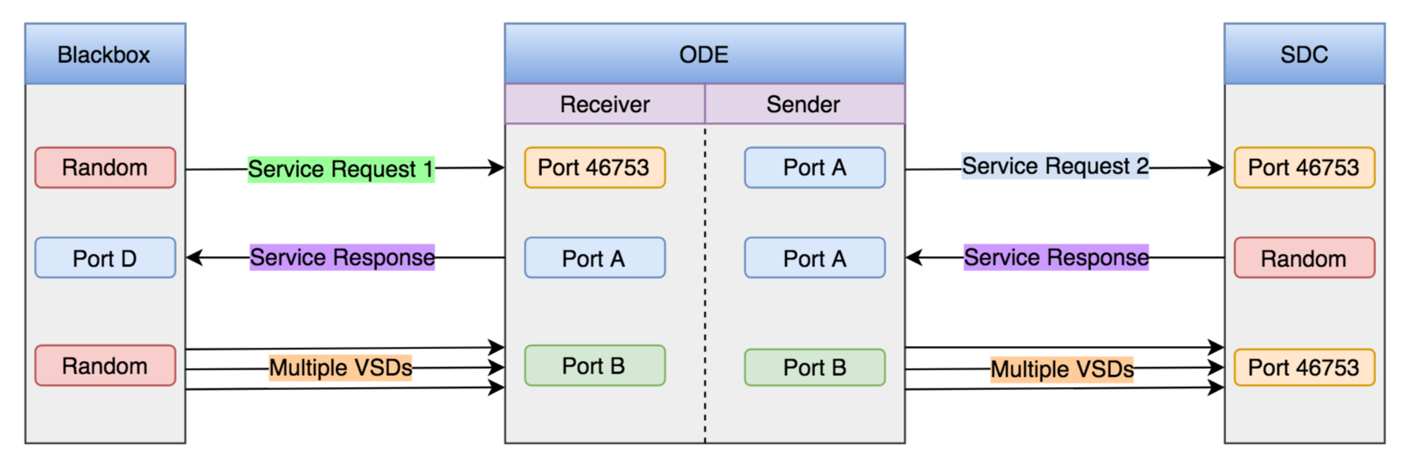
Figure 2 - VSD Dialog Flow Diagram

Notes for Figure 2:
- Random Ports: These ports could have a range of values.
- Port A: Can be configured in application.properties
- Port B: Can be configured in application.properties
- Service Request 1: Original request whose destination field contains Port D
- Service Request 2: Modified request whose destination field contains Port A
- Firewall rules should be configured to allow inbound and outbound ports for ODE.

VSD Receiver Service Messages and Alerts
Table 1 provides a detailed list of the VSD Receiver Service messages and alerts.
Table 1 – VSD Receiver Service Messages and Alerts
Message or Alert | Communication Method | Description | Criteria
- "Error creating socket with port {}"  - SocketException | Application log file | When the VSDM receiver is initialized, a datagram socket is created to listen for incoming messages from black box. This error message is logged when ODE fails to create a new datagram socket due to port being bound to some other program or some other reasons. | If the port is already bound to some other program or if the socket creation fails for some other reason, this message is logged in the application log file.
- Error receiving packet  - IOException | Application log file | When the ODE waits for packets from black box, this error message may be logged if the datagram socket fails to receive any packets due to IOException with the socket. | If the listening datagram socket fails to receive incoming packets from black box, this message is logged in the application log file.
- Unknown message type received {} | Application log file | When the VSDM receiver receives a packet from black box, it decodes the packet first. This message is logged if the decoded packet is of type other than ServiceRequest or VehSitDataMessage. | If the packet received from black box and decoded on the receiver end is of unknown message type, then this message is logged in the application log file.
- Unable to decode UDP message {}  - DecodeFailedException  - DecodeNotSupportedException | Application log file | When ODE receives any packet from black box, the receiver service tries to decode the packet first. This message is logged if the decoder fails to properly decode the packet. | If the receiver service fails to properly decode the incoming packets from black box, this message is logged in the application log file.
- Unable to convert VehSitDataMessage bundle to BSM list.  - IllegalArgumentException | Application log file | When the receiver receives VSD, it tries to extract BSMs out of the VSD. This error message is logged if the VSD bundle doesn’t have any BSM records. | If the VSDM receiver receives a VSD that doesn’t contain any BSM records, this message is logged in the application log file.
- Unable to convert BSM  - OssBsmPart2Exception | Application log file | When the VSDM receiver extracts BSMs from VSD, it tries to convert the generic BSM into J2735BSM format. This error message is logged if the receiver fails to properly perform conversion to J2735BSM format. | If the VSDM receiver fails to convert generic BSM to J2735BSM, this message is logged in the application log file.

BSM Receive Service via UDP
The ODE receives BSM messages via UDP/IP at its BSM Receiver service on the default port 46800 which can be changed through ode properties. BSM dialog does not include trust establishment phase, hence the BSMs are directly sent to ODE. Once BSMs are received, they will be published to the BSM kafka topics. [ODE-314] BSM Process then consumes the BSMs from the corresponding kafka topics. The consumed BSMs will then be inserted into a hash map where the keys will be the temp ID of the BSM and the value will be a queue of corresponding BSMs with the particular tempID. When a BSM is inserted to the queue, it will check if the queue has 10 BSMs. In the case that the queue has 10 BSMs, it will package them into VSD and publish it to the VSD kafka topic. Else, it will wait for more incoming BSMs.

BSM Receiver Service Messages and Alerts
Table 1 provides a detailed list of the BSM Receiver Service messages and alerts.
Table 1 – BSM Receiver Service Messages and Alerts
Message or Alert | Communication Method | Description | Criteria
- "Error creating socket with port {}"  - SocketException | Application log file | When the BSM receiver is initialized, a datagram socket is created to listen for incoming messages from OBU. This error message is logged when ODE fails to create a new datagram socket due to port being bound to some other program or some other reasons. | If the port is already bound to some other program or if the socket creation fails for some other reason, this message is logged in the application log file.
- Error receiving packet  - IOException | Application log file | When the ODE waits for packets from OBU, this error message may be logged if the datagram socket fails to receive any packets due to IOException with the socket. | If the listening datagram socket fails to receive incoming packets from OBU, this message is logged in the application log file.
- Unknown message type received {} | Application log file | When the BSM receiver receives a packet from OBU, it decodes the packet first. This message is logged if the decoded packet is of type other than J2735Bsm. | If the packet received from OBU and decoded on the receiver end is of unknown message type, then this message is logged in the application log file.

Appendix A: ODE Interface Specification
Field devices and TMC applications interface with the ODE for both sending and receiving data to and from the ODE
Ode provides two methods of accepting data from field devices:
- File copy: described in section 7.1
- RESTful API: upload described in section 7.2
ODE provides several methods for the TMC applications (or any ODE client application) to send and receive data to and from the ODE
- RESTful API: upload described in section 7.2
- Streaming API: described in section 7.3.
All of the above interfaces can be secured using SSL encryption.

File Copy Data Deposit
The File copy method is achieved by providing a configurable location on a shared file system where field devices will be able to deposit their data files and log files for processing. The upload location is specified by the application properties ode.uploadLocationRoot/ode.uploadLocationObuLog. If not specified, default locations would be uploads/bsmlog sub-directory off of the location where ODE is launched. ODE creates the specified directories if they do not exist.
Once the ODE processes the received file, it moves it to the “ode.uploadLocationRoot/backup” sub-directory. The backed-up file is renamed with a timestamp in milliseconds. If the ODE fails to process a file, it instead moves the file to the “ode.uploadLocationRoot/failed” sub-directory.
The files copied to “ode.uploadLocationObuLog” are treated as binary data of variable length records conforming to the specification in “data/wydotLogRecords_Tony.h” file. No header information is expected to precede each record.
Field Name | Field Length (bytes) | Description
direction | 1 | Represents the source of the BSM. 0 for EV(Tx), 1 for RV(Rx)
utctimeInSec | 4 | UTC time in seconds from Epoc 1/1/1970
mSec | 2 | milliseconds part of UTC time
verificationStatus | 1 | contains a SecurtyStatusCode as defined below:  typedef enum _securityResultCode { /* from dot3 */  success = 0,  inconsistentInputParameters = 2,  spduParsingInvalidInput = 3,  spduParsingUnsupportedCriticalInformationField = 4,  spduParsingCertificateNotFound = 5,  spduParsingGenerationTimeNotAvailable = 6,  spduParsingGenerationLocationNotAvailable = 7,  spduCertificateChainNotEnoughInformationToConstructChain = 8,  spduCertificateChainChainEndedAtUntrustedRoot = 9,  spduCertificateChainChainWasTooLongForImplementation = 10,  spduCertificateChainCertificateRevoked = 11,  spduCertificateChainOverdueCRL = 12,  spduCertificateChainInconsistentExpiryTimes = 13,  spduCertificateChainInconsistentStartTimes = 14,  spduCertificateChainInconsistentChainPermissions = 15,  spduCryptoVerificationFailure = 16,  spduConsistencyFutureCertificateAtGenerationTime = 17,  spduConsistencyExpiredCertificateAtGenerationTime = 18,  spduConsistencyExpiryDateTooEarly = 19,  spduConsistencyExpiryDateTooLate = 20,  spduConsistencyGenerationLocationOutsideValidityRegion = 21,  spduConsistencyNoGenerationLocation = 22,  spduConsistencyUnauthorizedPSID = 23,  spduInternalConsistencyExpiryTimeBeforeGenerationTime = 24,  spduInternalConsistencyextDataHashDoesntMatch = 25,  spduInternalConsistencynoExtDataHashProvided = 26,  spduInternalConsistencynoExtDataHashPresent = 27,  spduLocalConsistencyPSIDsDontMatch = 28,  spduLocalConsistencyChainWasTooLongForSDEE = 29,  spduRelevanceGenerationTimeTooFarInPast = 30,  spduRelevanceGenerationTimeTooFarInFuture = 31,  spduRelevanceExpiryTimeInPast = 32,  spduRelevanceGenerationLocationTooDistant = 33,  spduRelevanceReplayedSpdu = 34,  spduCertificateExpired = 35  } securityResultCode;
curLocation | location | The location and speed of the vehicle receiving and reporting the event.  /* below elements units are as per SAE-2735 */  typedef struct _location {  uint32_t latitude;  uint32_t longitude;  uint32_t elevation;  uint16_t speed;  uint16_t heading;  } __attribute__((__packed__)) location;
rxFrom | rxSource | The source of the message received:  typedef enum _rxSource {  RSU = 0,  SAT, //XM satelite  RV, /* for BSM rx */  SNMP /* for SRM payload from backend/ODE*/  } rxSource;
latitude | 4 | The latitude of the vehicle receiving and reporting the event.
longitude | 4 | The longitude of the vehicle receiving and reporting the event.
elevation | 4 | The elevation of the vehicle receiving and reporting the event.
speed | 2 | The speed of the vehicle receiving and reporting the event.
heading | 2 | The heading of the vehicle receiving and reporting the event.
length | 2 | Length of data contained in the following payload
payload | 2302 | RAW encoded data in 1609.2 format containing a MessageFrame header plus BSM or raw BSM
ODE will use utctimeInSec plus mSec fields to populate the generatedAt field of the output messages if and only if the payload is not signed with a valid signature. If the payload contains a valid 1609.2 signature, the generationTime from 1609.2 header will be used.

Messages and Alerts
This interface uses the file system to copy a file from source to destination. As a result, the messages and alerts generated by the copy command are platform dependent. The following table describes a sample set of exit codes returned by scp command but they may differ from the system on which ODE is deployed and running.

Table 1 - SCP Return Codes
0 | Operation was successful
1 | General error in file copy
2 | Destination is not directory, but it should be
3 | Maximum symlink level exceeded
4 | Connecting to host failed.
5 | Connection broken
6 | File does not exist
7 | No permission to access file.
8 | General error in sftp protocol
9 | File transfer protocol mismatch
10 | No file matches a given criteria
65 | Host not allowed to connect
66 | General error in ssh protocol
67 | Key exchange failed
68 | Reserved
69 | MAC error
70 | Compression error
71 | Service not available
72 | Protocol version not supported
73 | Host key not verifiable
74 | Connection failed
75 | Disconnected by application
76 | Too many connections
77 | Authentication cancelled by user
78 | No more authentication methods available
79 | Invalid user name

Table 2 - File Copy Data Deposit Messages and Alerts
Message or Alert | Communication Method | Description | Criteria
See Table 1 - SCP Return Codes for “copy” function Messages and Alerts | Command exit code | See Table 1 - SCP Return Codes for “copy” function Messages and Alerts | Platform dependent
Post-copy:  - “IMPORTER - Failed to open or process file: {}”  - FileNotFoundException | Application log file | When a data file is copied into one of the ODE upload folders, ODE will try to open the file and process its content. This error message is logged when ODE fails to open the file due to file not being present. | If the file does not exist when ODE starts to process it or for some other reason cannot be opened for reading, this message is logged in the application log file.
- “IMPORTER - Failed to open or process file: {}”  - SecurityException | Application log file | When a data file is copied into one of the ODE upload folders, ODE will try to open the file and process its content. This error message is logged when ODE fails to read the file due to lack of Java security privileges. | If a security manager exists and its checkRead method denies read access to the file, a message will be logged to the application log file.”
- “IMPORTER - Failed to open or process file: {}”  - "Error decoding data." | Application log file | When a data file is copied into one of the ODE upload folders, ODE will try to open the file and process its content. This error message is logged when ODE fails to decode the data from ASN.1 format. | If the message is not encoded to the expected ASN.1 encoding, ODE will raise this error to indicate failure to decode the data.

ODE REST API
ODE exposes a RESTful API for use by clients for security, administrative and data functions. Standard HTTP/HTTPS verbs such as GET, POST, PUT, DELETE, etc., will be deployed for various functions.
- host: ip:port
- root context path: ode/api/rest
- schemes:
- - http
- - https

The REST API is documented using Swagger and can be found at https://usdot-jpo-ode.github.io/ - this document is also located in the repository at docs/ODESwagger.yml.

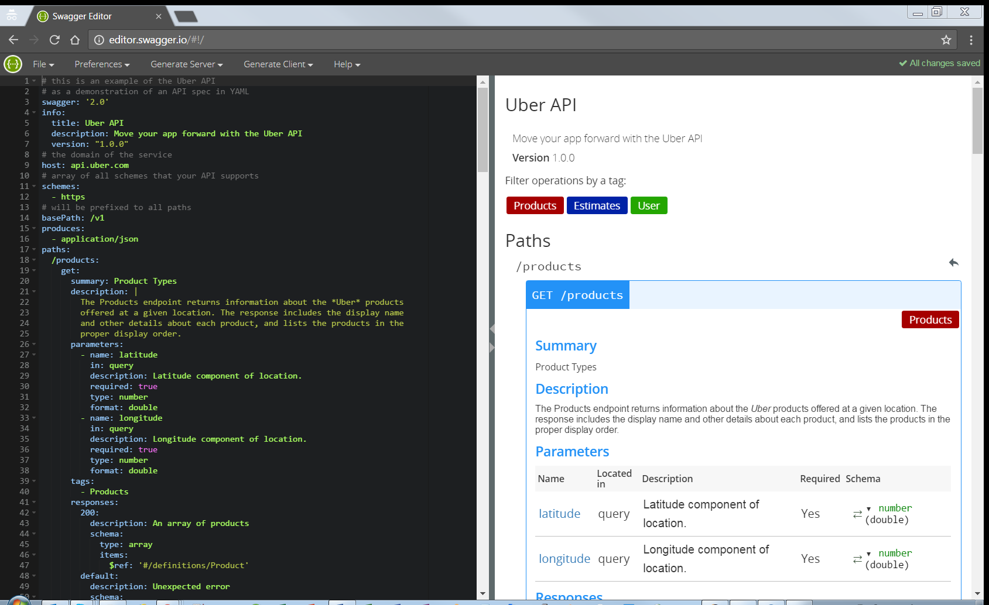
Figure 3 - ODE REST API Editor Tool

Upload BSM File
ODE Web UI uses the following http REST call to deposit a file to one of the supported upload directories.
Path | upload/<type:bsmlog>
Verb | POST
Summary | Service to upload a file containing BSM records
Consumes | - multi-part/file
Produces | - application/json
Headers | Name Value Description Required (T | F)  Token Value of token Valid security token True
Parameters | Name Value Description Required In (Q|B)  type bsmlog The type of file being uploaded. True Q
Responses | Code Description Schema  200 Upload was successful {Status:success}  HTTP Status code Description of the response Schema of the response body
Table 3 - Upload BSM File API
STATUS: A prototype upload BSM File API has been implemented but requires minor modifications to comply with the above specifications.

MANAGE SNMP API
Over an SNMP Protocol, the ODE can ping and assess the health of an existing Road Side Unit to ensure the system is up and running. To trigger a specific heartbeat call, the ODE provides two separate interfaces to deploy a message to an RSU.

MANAGE SNMP API - Web Based View
To connect heartbeat service is through the existing web interface located at the root of the application. On it, a user will see a section for RSU SNMP Query and may enter in the same IP and OID information as the API Endpoint.

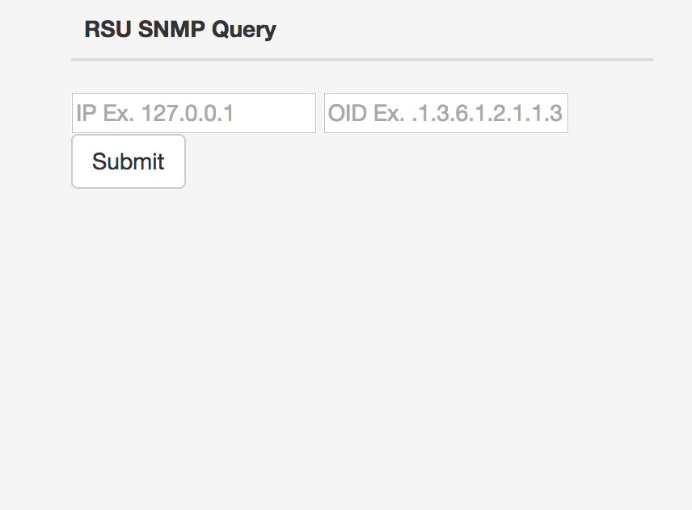

MANAGE SNMP API – REST Interface
To interface with the ODE through its REST API, the client needs to use the following parameters:
host: <Host server IP address or DNS name>
basePath: /rsuHeartbeat?ip=<ip_address>&oid=<oid_string>
You should receive a detailed plain text response that looks like the following example. If the device is off, a 4 second timeout will occur and the ODE will indicate this with an "[ERROR] Empty response" message. (This specific OID returns the amount of time since the device was last powered on)
[1.3.6.1.2.1.1.3.0 = 0:05:12.59]

Traveler Information Message (TIM) Interface
Refer to the ODESwagger.yaml for details of the TIM interface.

Probe Data Management Messages (PDM) Interface
Refer to the ODESwagger.yaml for details of the PDM interface.

ODE Streaming API
ODE client applications will be able to subscribe to data streams via two distinct but dependent interfaces.
- Clients may interface directly or through proxies with Kafka brokers to subscribe to a well-known topics. See section 7.3.1 for details.
- Clients may Interface directly with ODE through ODE provided WebSocket interface as defined by RFC 6455 (http://tools.ietf.org/html/rfc6455 ). See section 7.3.2 for details.

Direct Kafka Interface
To interface with Kafka directly, the client needs to know the list of available Kafka brokers and the name of the topic that will contain the data. The client application may use any of the following methods to access Kafka topics:
- Native Kafka API (C, Java, Python, etc.)
- Kafka API RESTful Proxy such as: https://www.confluent.io/blog/a-comprehensive-open-source-rest-proxy-for-kafka/
- Kafka API WebSocket Proxy such as: https://github.com/b/kafka-websocket/blob/master/pom.xml
A sample Java client will be available in the ODE source repository under jpo-ode-consumer-example project.

Kafka Publish/Subscribe Topics
The following table contains the name of the topics and the type of data in each topic.
Topic Name | Data Type | Format
topic.OdeBsmPojo | us.dot.its.jpo.ode.model.OdeBsmData | Serialized POJO
topic.OdeBsmJson | us.dot.its.jpo.ode.model.OdeBsmData | JSON
topic.OdeBsmRxPojo | us.dot.its.jpo.ode.model.OdeBsmData | Serialized POJO
topic.OdeBsmTxPojo | us.dot.its.jpo.ode.model.OdeBsmData | Serialized POJO
topic.OdeBsmDuringEventPojo | us.dot.its.jpo.ode.model.OdeBsmData | Serialized POJO
topic.FilteredOdeBsmJson | us.dot.its.jpo.ode.model.OdeBsmData | JSON
topic.OdeTimPojo | us.dot.its.jpo.ode.model.OdeTimData | Serialized POJO
topic.OdeTimJson | us.dot.its.jpo.ode.model.OdeTimData | JSON
topic.OdeDNMsgJson | J2735 TravelerInformation | XML/ASN.1 XER Format
topic.OdeTimRxJson | J2735 TravelerInformation | ASN.1 XER Format
topic.OdeTimBroadcastPojo | us.dot.its.jpo.ode.model.OdeTimData | Serialized POJO
topic.OdeTimBroadcastJson | us.dot.its.jpo.ode.model.OdeTimData | JSON
topic.Asn1DecoderInput | us.dot.its.jpo.ode.model.OdeAsn1Data | XML/ASN.1 XER Format
topic.Asn1DecoderOutput | us.dot.its.jpo.ode.model.OdeAsn1Data | XML/ASN.1 XER Format
topic.Asn1EncoderInput | us.dot.its.jpo.ode.model.OdeAsn1Data | XML/ASN.1 XER Format
topic.Asn1EncoderInput | us.dot.its.jpo.ode.model.OdeAsn1Data | XML/ASN.1 XER Format
Table 6 - Kafka Publish/Subscribe Topics

ODE WebSocket Interface
To interface with the ODE through its WebSocket interface, the client needs to know use the following parameters:
host: <Host server IP address or DNS name>
basePath: /ode/api/ws
schemes:
- ws
- wss

ODE WebSocket Control Messages
The response to a streaming data requests may contain control messages such as CONNECT, START, STOP, etc. Here is a sample Control Message.
{"metadata":{"payloadType":"control","version":1},"payload":{"dataSourceBundleCount":20,"receivedRecordCount":203,"sentRecordCount":10,"tag":"STOP","dataType":"Control","version":1},"version":1}
For detailed schema of ODE Control messages see section 8.2.6.
STATUS: Control Messages have not been implemented yet.

BSM WebSocket Subscription API
STATUS: A prototype BSM WebSocket Subscription API has been implemented but requires modifications to comply with the above specifications.
Path | /obulog
Summary | Subscription request for data
Consumes | - application/json
Produces | - application/json
Parameters | Name Value Description Required In  request Subscription Request (see section 8.1.1) The subscription request parameters true body  token string A valid security token obtained from login service true query-param
Responses | Code Description Schema  0 SUCCESS See Table 6  1 FAILURE OdeStatus  2 SOURCE_CONNECTION_ERROR OdeStatus  3 INVALID_REQUEST_TYPE_ERROR OdeStatus  4 INVALID_DATA_TYPE_ERROR OdeStatus

ODE Request Schemas
The following sub-sections describe the structure and specification of ODE request messages.

ODE Request Message Metadata
Every ODE Request message component will contain the following data element.

Name | Required / Optional (R | O) | Type | Description | Units | Valid Min | Valid Max | Default
schemaVersion | O | Integer | The version number for this schema. See section 8 for details. | N/A | 0 (latest) | MAX INT | 0
Table 7 – ODE Request Message Metadata

ODE Response Schemas
The following sub-sections describe the structure and specification of ODE messages returned as response to data requests. Figure 4 illustrates the class hierarchy for ODE Data output schema.

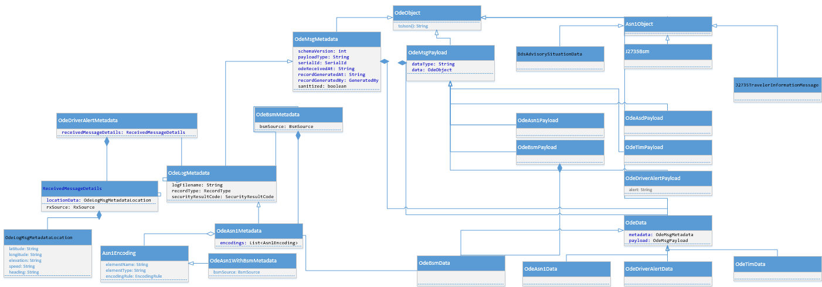
Figure 4 - ODE Data Class Hierarchy
A simplified version of the class hierarchy are described in the following sections

ODE Data
The top level structure of ODE Data Message is defined in the Table 8below:
Name | Type | Description | Units | Valid Min | Valid Max
metadata | One of OdeMsgMetadata types | See section 8.2.2
payload | One of OdeMsgPayload types. | See section 8.2.7 and its subsections

Table 8 – OdeData
Figure 5 below represents the OdeData inheritance hierarchy
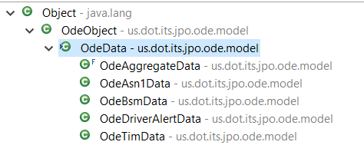
Figure 5 - OdeData Inheritance Hierarchy

ODE Message Metadata
The structure of OdeMsgMetadata is defined in Table 9 below.

Name | Type | Description | Units | Valid Min | Valid Max
payloadType | String | One of: "status", "control", "security", "bsm", "tim", "map", "spat", "other" | enum
odeReceivedAt | iso-date-time | The date and time that the payload paired with this metadata was received by the ODE. | ISO standard format include time zone: yyyy-MM-ddThh:mm:ss.sssZ
serialId | String | A unique serial number representing this record. | N/A | N/A | N/A
schemaVersion | Integer | The version number for this schema. See section 8 for details. | N/A | 1 | MAX INT
recordGeneratedAt | iso-date-time | The date and time that the data was generated at the source defined by recordGeneratedBy | ISO standard format include time zone: yyyy-MM-ddThh:mm:ss.sssZ
recordGeneratedBy | GeneratedBy | An enumeration value:  public enum GeneratedBy  {TMC, OBU, RSU}
sanitized | Boolean | True if the record has been processed by a privacy protection module.
logFileName | String | Simple name of the log file ingested. This element is defined in OdeLogMetadata
recordType | RecordType | One of enum RecordType constants {bsmLogDuringEvent, rxMsg, dnMsg, bsmTx, driverAlert, unsupported}. This element is defined in OdeLogMetadata
securityResultCode | SecurityResultCode | One of enum constant SecurityResultCode {success, unknown, inconsistentInputParameters, spduParsingInvalidInput, spduParsingUnsupportedCriticalInformationField, spduParsingCertificateNotFound, spduParsingGenerationTimeNotAvailable, spduParsingGenerationLocationNotAvailable, spduCertificateChainNotEnoughInformationToConstructChain, spduCertificateChainChainEndedAtUntrustedRoot, spduCertificateChainChainWasTooLongForImplementation, spduCertificateChainCertificateRevoked, spduCertificateChainOverdueCRL, spduCertificateChainInconsistentExpiryTimes, spduCertificateChainInconsistentStartTimes, spduCertificateChainInconsistentChainPermissions, spduCryptoVerificationFailure, spduConsistencyFutureCertificateAtGenerationTime, spduConsistencyExpiredCertificateAtGenerationTime, spduConsistencyExpiryDateTooEarly, spduConsistencyExpiryDateTooLate, spduConsistencyGenerationLocationOutsideValidityRegion, spduConsistencyNoGenerationLocation, spduConsistencyUnauthorizedPSID, spduInternalConsistencyExpiryTimeBeforeGenerationTime, spduInternalConsistencyextDataHashDoesntMatch, spduInternalConsistencynoExtDataHashProvided, spduInternalConsistencynoExtDataHashPresent, spduLocalConsistencyPSIDsDontMatch, spduLocalConsistencyChainWasTooLongForSDEE, spduRelevanceGenerationTimeTooFarInPast, spduRelevanceGenerationTimeTooFarInFuture, spduRelevanceExpiryTimeInPast, spduRelevanceGenerationLocationTooDistant, spduRelevanceReplayedSpdu, spduCertificateExpired}. This element is defined in OdeLogMetadata
Encodings | List<Asn1Encoding> | A list of Asn1Encodings:  Name Type Description  elementName String Name of element to be ASN.1 encoded  elementType String ASN.1 type/data structure to be encoded  encodingRule EncodingRule One of the following enum constant: enum EncodingRule {UPER, COER}  This element is defined in OdeAsn1Metadata
bsmSource | BsmSource | One of enum BsmSource {EV, RV, unknown} constants. This element is defined in OdeBsmMetadta and OdeAsn1WithBsmMetadata
receivedMessageDetails | ReceivedMessageDetails | This element is a data structure as defined below:  Name Type Description  locationData OdeLogMsgMetadataLocation A data structure containing the following: String latitude; String longitude; String elevation; String speed; String heading;  This data element is defined in OdeDriverAlertMetadata and OdeTimMetadata
Table 9 – OdeMsgMetadata
The inheritance hierarchy of OdeMsgMetadata is represented in Figure 6 below:
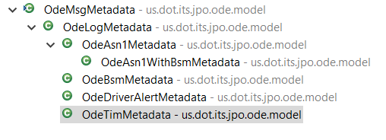
Figure 6 - OdeMsgMetadata Inheritance Hierarchy

ODE Payload Violation
STATUS: ODE Payload Violations schema have not yet been implemented.
Name | Type | Description | Units | Valid Min | Valid Max
actualValue | Decimal | The actual value of the field | The Unit of measure of the fieldName | Min Decimal | Max Decimal
fieldName | String | The name of the payload field for which violation was detected. | N/A
validMax | Decimal | Maximum value considered to be valid. | The Unit of measure of the fieldName
validMin | Decimal | Minimum value considered to be valid | The Unit of measure of the fieldName

ODE GET TOKEN Response
STATUS: ODE Get Token Response Message has not yet been implemented

Name | Type | Description | Units | Valid Min | Valid Max
dataType | String | Authorization response type | Enum | "security" | "security"
version | Integer | The version number for this schema. See section 8 for details. | N/A | 1 | MAX INT
Table 10 - OdeAuthentication

ODE Status Message
STATUS: ODE Status Message has not yet been implemented

Name | Type | Description | Units | Valid Min | Valid Max
status | String | Request status | Enum | "status" | "status"
version | Integer | The version number for this schema. See section 8 for details. | N/A | 1 | MAX INT
Table 11 - OdeStatus

ODE Control Message
STATUS: ODE Control Message has not yet been implemented

Name | Type | Description | Units | Valid Min | Valid Max
dataSourceBundleCount | Integer | Number of records in a bundle reported by the data source | Count | 0 | 9223372036854775807
receivedRecordCount | Integer | Number of messages received by the ODE | Count | 0 | 9223372036854775807
sentRecordCount | Integer | Number of records sent by the ODE to the client | Count | 0 | 9223372036854775807
tag | Enum | The control message event tag | Enum | One of CONNECTED, START, STOP, ERROR | One of CONNECTED, START, STOP, ERROR
version | Integer | The version number for this schema. See section 8 for details. | N/A | 1 | MAX INT
Table 12 - OdeControlData

ODE Data Message Payload

OdeMsgPayload is the parent class for all payload data structures, each of which contain the following data elements.
Name | Type | Description | Units | Valid Min | Valid Max
dataType | String | The type of data contained in the data element. | N/A | N/A | N/A
Data | OdeObject | The data within this payload | N/A | N/A | N/A
Table 13 – OdeMsgPayload
The inheritance hierarchy of OdeMsgPayload is illustrated in Figure 7 below
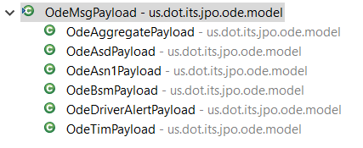
Figure 7 - OdeMsgPayload Inheritance Hierarchy

The following subsection describe the child schemas of OdeMsgPayload.

J2735 BSM Data

Name | Type | Description | Units | Valid Min | Valid Max
coreData | J2735BsmCoreData | See section 8.2.8.1 | N/A | N/A | N/A
partII | Array of J2735BsmPart2Content | See section 8.2.8.2 | N/A | N/A | N/A
version | Integer | The version number for this schema. See section 8 for details. | N/A | 1 | MAX INT

ODE Data Message Supporting Data Structures
The data structures described in this section and subsections are referenced by top level ODE data message schemas.

J2735BsmCoreData

Name | Type | Description | Units | Valid Min | Valid Max
msgCnt | Integer
id | String
secMark | Integer
position | J2735Position3D
accelSet | J2735AccelerationSet4Way
accuracy | J2735PositionalAccuracy
transmission | enum | One of:  - neutral, // Neutral, speed relative to the vehicle alignment  - park, // Park, speed relative the to vehicle alignment  - forwardGears, // Forward gears, speed relative the to vehicle alignment  - reverseGears, // Reverse gears, speed relative the to vehicle alignment  - reserved1, reserved2, reserved3, unavailable; // not-equipped or unavailable  // value,
speed | decimal | Vehicle speed | m/s | 0 | 163.8
heading | decimal | Vehicle heading | Degrees | 0.000 | 360.000
angle | decimal | Steering wheel angle | Degrees | 0.000 | 360.000
brakes | J2735BrakeSystemStatus
size | J2735VehicleSize

J2735BsmPart2Content

Name | Type | Description | Units | Valid Min | Valid Max
id | enum | One of:  - vehicleSafetyExt  - specialVehicleExt  - supplementalVehicleExt
value | J2735BsmPart2Extension | One of the following object types:  - J2735VehicleSafetyExtensions  - J2735SpecialVehicleExtensions  - J2735SupplementalVehicleExtensions

J2735Position3D

Name | Type | Description | Units | Valid Min | Valid Max
elevation | decimal | Elevation | meters | -409.5 | 6143.9
latitude | decimal | Position latitude | Degrees | -90.0000000 | +90.0000000
longitude | decimal | Position longitude | Degrees | -180.0000000 | *180.0000000
Table 14 - OdePosition3D

J2735AccelerationSet4Way

Name | Type | Description | Units | Valid Min | Valid Max
accelLat | decimal | Latitudinal acceleration, i.e. acceleration perpendicular to the direction of travel. | m/s² | -20.00 | +20.00
accelLong | decimal | Longitudinal acceleration, i.e. acceleration in the direction of travel. | m/s² | -20.00 | +20.00
accelVert | decimal | Vertical acceleration, i.e. acceleration along the z-axis | G | -3.4 | +1.54
accelYaw | decimal | Rotational acceleration around the z axis | Degrees/sec | -327.67 | +327.67

J2735PositionalAccuracy
Name | Type | Description | Units | Valid Min | Valid Max
semiMajor | decimal
semiMinor | decimal
orientation | decimal

J2735BrakeSystemStatus
Name | Type | Description | Units | Valid Min | Valid Max
wheelBrakes | J2735BitString | A Boolean dictionary of the following indicators:  - unavailable -- When set, the brake applied status is unavailable  - leftFront -- Left Front Active  - leftRear -- Left Rear Active  - rightFront -- Right Front Active  - rightRear -- Right Rear Active
traction | enum | One of:  - unavailable -- B'00 Not Equipped with traction control or traction control status is unavailable  - off -- B'01 traction control is Off  - on -- B'10 traction control is On (but not Engaged)  - engaged -- B'11 traction control is Engaged
abs | enum | One of:  - unavailable -- B'00 Vehicle Not Equipped with ABS Brakes or ABS Brakes status is unavailable  - off -- B'01 Vehicle's ABS are Off  - on -- B'10 Vehicle's ABS are On ( but not Engaged )  - engaged -- B'11 Vehicle's ABS control is Engaged on any wheel
scs | enum | One of:  - unavailable, -- B'00 Not Equipped with SC or SC status is unavailable  - off, -- B'01 Off  - on, -- B'10 On or active (but not engaged)  - engaged -- B'11 stability control is Engaged
brakeBoost | enum | One of:  - unavailable, -- Vehicle not equipped with brake boost or brake boost data is unavailable  - off, -- Vehicle's brake boost is off  - on -- Vehicle's brake boost is on (applied)
auxBrakes | enum | One of:  - unavailable -- B'00 Vehicle Not Equipped with Aux Brakes or Aux Brakes status is unavailable  - Off -- B'01 Vehicle's Aux Brakes are Off  - on -- B'10 Vehicle's Aux Brakes are On ( Engaged )  - reserved -- B'11

J2735VehicleSize
Name | Type | Description | Units | Valid Min | Valid Max
length | integer | Vehicle length | Centimeter | 0 | 16383
width | integer | Vehicle Width | Centimeter | 0 | 1023

J2735BitString
A J2735BitString is represented by a Boolean dictionary, a collection of name-value pairs where the name identifies a Boolean indicator and the value represents the state of the indicator as true or false.

J2735VehicleSafetyExtensions
Name | Type | Description | Units | Valid Min | Valid Max
events | J2735BitString | A Boolean dictionary of the following indicators:  - eventHazardLights  - eventStopLineViolation -- Intersection Violation  - eventABSactivated  - eventTractionControlLoss  - eventStabilityControlactivated  - eventHazardousMaterials  - eventReserved1  - eventHardBraking  - eventLightsChanged  - eventWipersChanged  - eventFlatTire  - eventDisabledVehicle -- The DisabledVehicle DF may also be sent  - eventAirBagDeployment
pathHistory | J2735PathHistory
pathPrediction | J2735PathPrediction
lights | J2735BitString | A Boolean dictionary of the following indicators:  - lowBeamHeadlightsOn  - highBeamHeadlightsOn  - leftTurnSignalOn  - rightTurnSignalOn  - hazardSignalOn  - automaticLightControlOn  - daytimeRunningLightsOn  - fogLightOn  - parkingLightsOn

J2735SpecialVehicleExtensions

Name | Type | Description | Units | Valid Min | Valid Max
vehicleAlerts | J2735EmergencyDetails
description | J2735EventDescription
trailers | J2735TrailerData

J2735SupplementalVehicleExtensions

Name | Type | Description | Units | Valid Min | Valid Max
classification | Integer
classDetails | J2735VehicleClassification
vehicleData | J2735VehicleData
weatherReport | J2735WeatherReport
weatherProbe | J2735WeatherProbe
obstacle | J2735ObstacleDetection
status | J2735DisabledVehicle
speedProfile | J2735SpeedProfile
theRTCM | J2735RTCMPackage
regional | Array of J2735RegionalContent

J2735PathHistory

Name | Type | Description | Units | Valid Min | Valid Max
initialPosition | J2735FullPositionVector
currGNSSstatus | J2735BitString | A Boolean dictionary of the following indicators:  - unavailable -- Not Equipped or unavailable  - isHealthy  - isMonitored  - baseStationType -- Set to zero if a moving base station, or if a rover device (an OBU), set to one if it is a fixed base station  - aPDOPofUnder5 -- A dilution of precision greater than 5  - inViewOfUnder5 -- Less than 5 satellites in view  - localCorrectionsPresent -- DGPS type corrections used  - networkCorrectionsPresent -- RTK type corrections used
crumbData | Array of J2735PathHistoryPoint

J2735PathPrediction

Name | Type | Description | Units | Valid Min | Valid Max
confidence | decimal | Confidence | percent | 0 | 100
radiusOfCurve | decimal | Radius of curve | centimeters | 0 | TBD

J2735EmergencyDetails

Name | Type | Description | Units | Valid Min | Valid Max
sspRights | Integer |  |  | 0 | 31
events | J2735BitString | A Boolean dictionary of the following indicators:  - peUnavailable -- Not Equipped or unavailable  - peEmergencyResponse -- The vehicle is a properly authorized public safety vehicle, is engaged in a service call, and is currently moving or is within the roadway. Note that lights and sirens may not be evident during any given response call  - Emergency and Non Emergency Lights related  - peEmergencyLightsActive  - peEmergencySoundActive  - peNonEmergencyLightsActive  - peNonEmergencySoundActive
lightsUse | Enum | One of:  - unavailable,  - notInUse,  - inUse,  - yellowCautionLights,  - schooldBusLights,  - arrowSignsActive,  - slowMovingVehicle,  - freqStops
multi | Enum | One of:  - unavailable,  - singleVehicle,  - multiVehicle,  - reserved
responseType | Enum | One of:  - notInUseOrNotEquipped,  - emergency,  - nonEmergency,  - pursuit,  - stationary,  - slowMoving,  - stopAndGoMovement
sirenUse | Enum | One of:  - unavailable,  - notInUse,  - inUse,  - reserved

J2735EventDescription

Name | Type | Description | Units | Valid Min | Valid Max
description | Array of integers | 1 to 8 ITIS.ITIScodes
extent | J2735Extent
heading | J2735BitString | A Boolean dictionary of the following indicators:  - from000-0to022-5degrees  - from022-5to045-0degrees  - from045-0to067-5degrees  - from067-5to090-0degrees  - from090-0to112-5degrees  - from112-5to135-0degrees  - from135-0to157-5degrees  - from157-5to180-0degrees  - from180-0to202-5degrees  - from202-5to225-0degrees  - from225-0to247-5degrees  - from247-5to270-0degrees  - from270-0to292-5degrees  - from292-5to315-0degrees  - from315-0to337-5degrees  - from337-5to360-0degrees
priority | Integer | The urgency of the message | N/A | 0 | 7
typeEvent | Integer | A code from the list of ITIS.ITIScodes | N/A | 0 | 65535
regional | Array of J2735RegionalContent

J2735TrailerData

Name | Type | Description | Units | Valid Min | Valid Max
sspRights | Integer |  |  | 0 | 31
connection | J2735PivotPointDescription
units | Array of J2735TrailerUnitDescription

J2735VehicleClassification

Name | Type | Description | Units | Valid Min | Valid Max
fuelType | Enum | One of:  - unknownFuel, // FuelType::= 0 -- Gasoline Powered  - gasoline, // FuelType::= 1  - ethanol, // FuelType::= 2 -- Including blends  - diesel, // FuelType::= 3 -- All types  - electric, // FuelType::= 4  - hybrid, // FuelType::= 5 -- All types  - hydrogen, // FuelType::= 6  - natGasLiquid, // FuelType::= 7 -- Liquefied  - natGasComp, // FuelType::= 8 -- Compressed  - propane // FuelType::= 9
hpmsType | Enum | One of:  - none,  - unknown,  - special,  - moto,  - car,  - carOther,  - bus,  - axleCnt2,  - axleCnt3,  - axleCnt4,  - axleCnt4Trailer,  - axleCnt5Trailer,  - axleCnt6Trailer,  - axleCnt5MultiTrailer,  - axleCnt6MultiTrailer,  - axleCnt7MultiTrailer
iso3883 | Integer | Iso3833VehicleType | N/A | 0 | 100
keyType | Integer | BasicVehicleClass | N/A | 0 | 255
responderType | Enum | One of:  - emergency_vehicle_units,  - federal_law_enforcement_units,  - state_police_units,  - county_police_units,  - local_police_units,  - ambulance_units,  - rescue_units,  - fire_units,  - hAZMAT_units,  - light_tow_unit,  - heavy_tow_unit,  - freeway_service_patrols,  - transportation_response_units,  - private_contractor_response_units

J2735VehicleData

Name | Type | Description | Units | Valid Min | Valid Max

J2735WeatherReport

Name | Type | Description | Units | Valid Min | Valid Max
weatherAirPres | decimal |  | hectopascals (hPa) | 580.0 | 1090.0
weatherAirTemp | decimal |  | Centigrade (Celcius) | -40.0 | 151.0

J2735WeatherProbe

Name | Type | Description | Units | Valid Min | Valid Max

J2735ObstacleDetection

Name | Type | Description | Units | Valid Min | Valid Max

J2735DisabledVehicle

Name | Type | Description | Units | Valid Min | Valid Max

J2735SpeedProfile

Name | Type | Description | Units | Valid Min | Valid Max

J2735RTCMPackage

Name | Type | Description | Units | Valid Min | Valid Max

J2735RegionalContent

Name | Type | Description | Units | Valid Min | Valid Max

J2735FullPositionVector

Name | Type | Description | Units | Valid Min | Valid Max

J2735PathHistoryPoint

Name | Type | Description | Units | Valid Min | Valid Max

J2735PrivilegedEvents

Name | Type | Description | Units | Valid Min | Valid Max

J2735LightbarInUse

Name | Type | Description | Units | Valid Min | Valid Max

J2735MultiVehicleResponse

Name | Type | Description | Units | Valid Min | Valid Max

J2735ResponseType

Name | Type | Description | Units | Valid Min | Valid Max

J2735SirenInUse

Name | Type | Description | Units | Valid Min | Valid Max

J2735Extent

Name | Type | Description | Units | Valid Min | Valid Max

J2735PivotPointDescription

Name | Type | Description | Units | Valid Min | Valid Max

J2735TrailerUnitDescription

Name | Type | Description | Units | Valid Min | Valid Max

J2735BumperHeights

Name | Type | Description | Units | Valid Min | Valid Max

J2735TrailerHistoryPoint

Name | Type | Description | Units | Valid Min | Valid Max

J2735Node_XY

Name | Type | Description | Units | Valid Min | Valid Max

Table 15 – BSM Data

OdeDateTime

Name | Type | Description | Units | Valid Min | Valid Max
day | Integer
hour | Integer
minute | Integer
month | Integer
second | Decimal
year | Integer
Table 16 - OdeDateTime

